**ASIC Verification Assignment Solution  
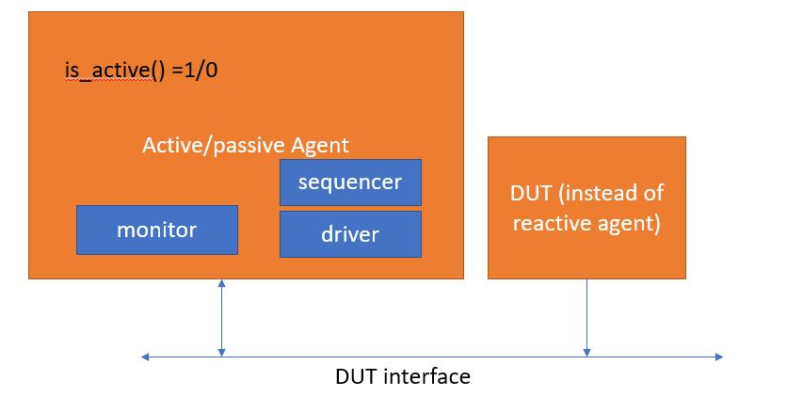  
Agent can be configured in env in build_phase by setting the “is_active” == 1.**

**Full testbench code running bringup test (dummy delay sequence)**

[**https://www.edaplayground.com/x/CzGt**](https://www.edaplayground.com/x/CzGt)

**Test can be passed in run options by passing +UVM_TESTNAME= “any test name from test_lib.sv”  
  
  
Assumptions made for the DUT-  
1) DUT absorbs all the data and control signals that are given to it without raising/asserting any error signal.  
2) DUT is always ready to accept given data.  
Assumptions made for the TB-**

1. **The DUT mimics the reactive agent.**
2. **The monitor and driver of active and passive agent has virtual interface handle of physical interface. So driver and monitor can drive and monitor subsequent data.**

**TestPlan:**

1. **Reset Scenario- While submitting random data, give reset and check whether all the control and data signals are resetted properly or not.**
2. **Non Reset Scenario-  
   i) Send Different combination of packets-  
   -Send Message passthrough data with message type “MASS_QUOTE, HEARTBEAT, RESERVED” and random data from 128 to 1017 bytes.  
    -Send Register write data with modes “NORMAL” and “BURST” and send random normal or burst mode data from 1 to 1016 bytes.**
3. **Assert in_error = 1 in the incoming data packet and check whether in_ready of DUT is getting asserted or not.**

**Knobs for controlling VIP -  
1) For controlling byte_0 of packet- `uvm_do_with(… req.** **pkt_transition_type_e == MESSAGE_PASSTHROUGH/REGISTER UPDATE/RESERVED_TX)**

**2) For controlling transaction header message type- `uvm_do_with(… req.msg_type_e == MASS_QUOTE/HEARTBEAT/RESERVED_MX_TYPE)**

**3) For controlling register write data format mode - `uvm_do_with(… req.mode_ee == NORMAL/BURST)**

**4) For controlling burst length of message pass through data - `uvm_do_with(…req.length_for_msg_pass_thru inside [128:1017]**

**5)For controlling burst length of register write data –   
`uvm_do_with(…req.length_for_reg_wr inside [1:1016]  
  
6) Activeness/passiveness of agent can be controlled like line 18 of env.sv or by creating a separate agent configuration object**